Project Name: Smart Weather
Client Name: BigBucks Café
Sprint Duration: Customized

Product Backlog:
Created 3 Epics as part of Version 1 i.e. Release 1
- Building Easy login for existing customers
- Should display popular items in the home page screen.
- Application should be integrated with auto detection of location when launched

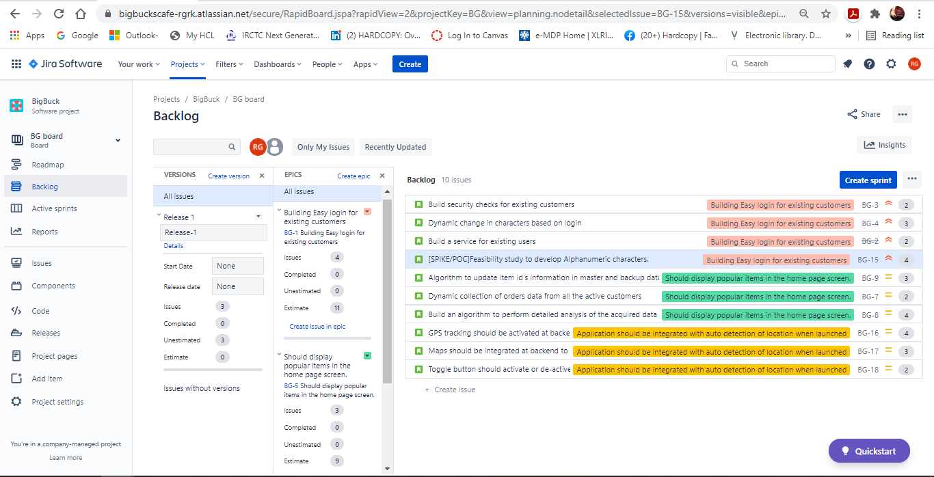
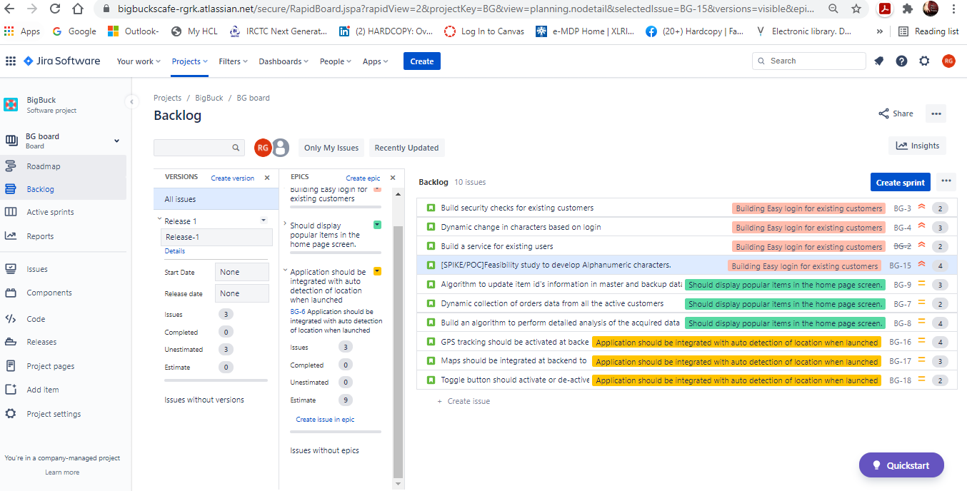
1. Building Easy login for existing customers
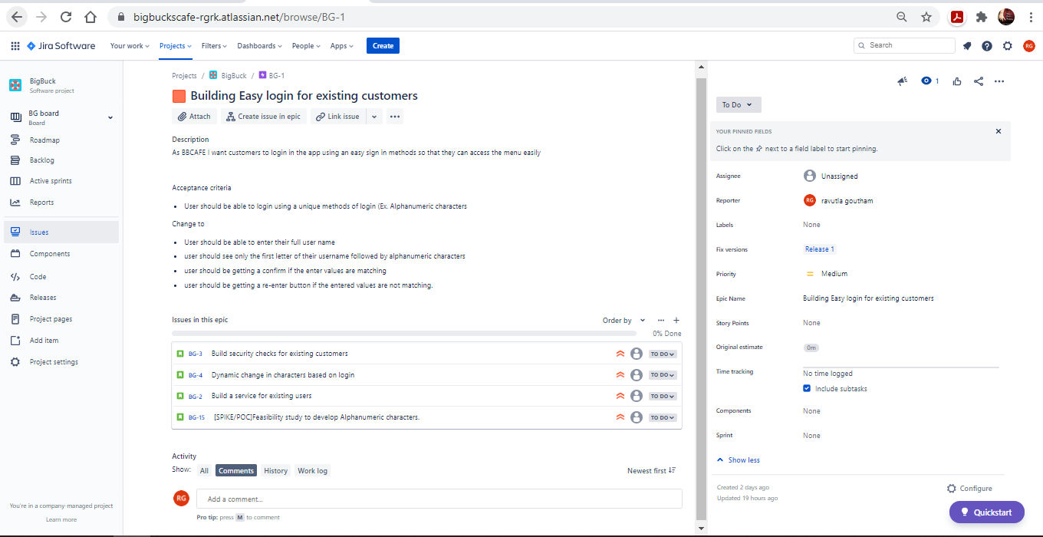

2. Should display popular items in the home page screen.
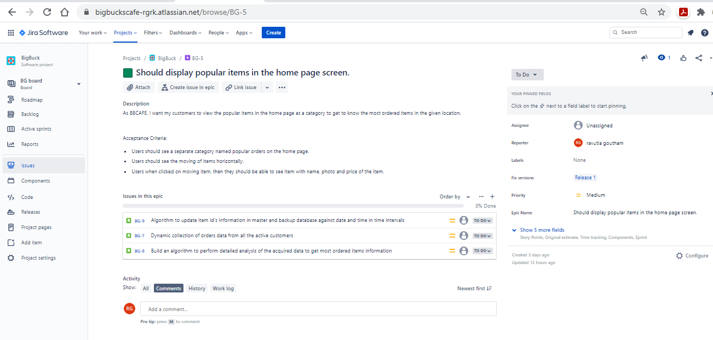

3. Application should be integrated with auto detection of location when launched
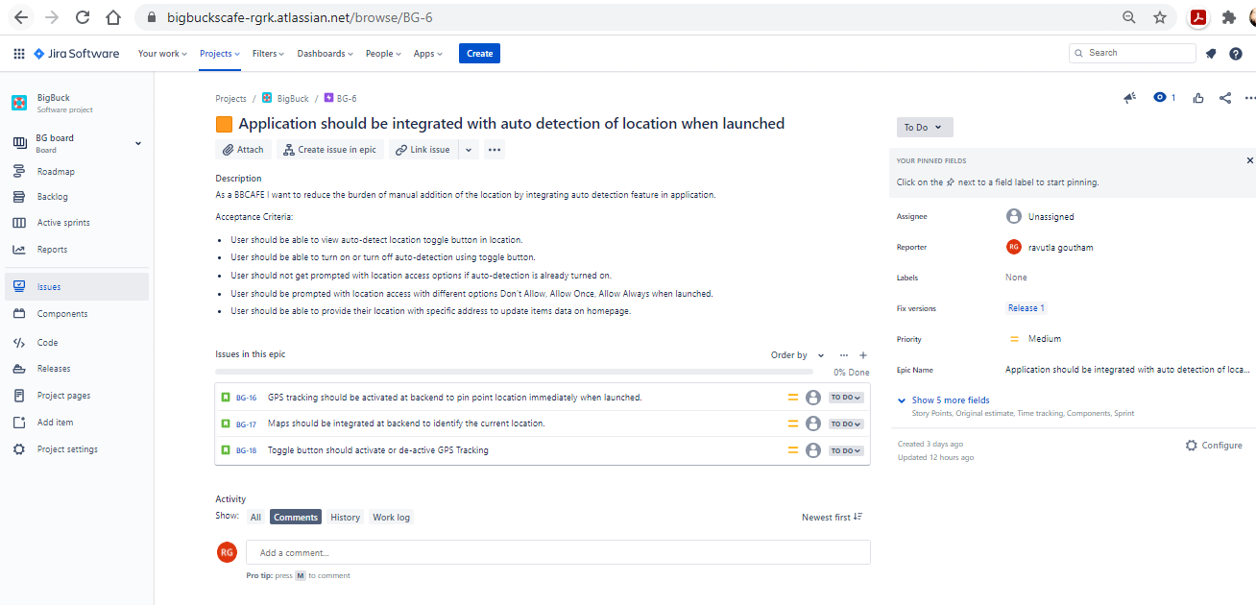

Sprint -1
Epic-3: Application should be integrated with auto detection of location when launched.
Story: Toggle button should activate or de-active GPS Tracking

To DO:
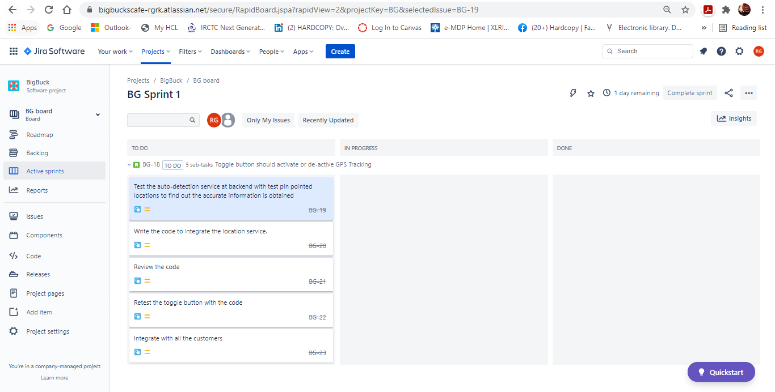

InProgress
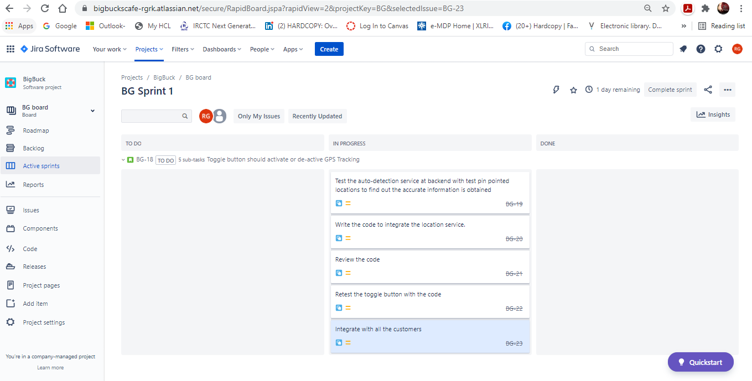
Done
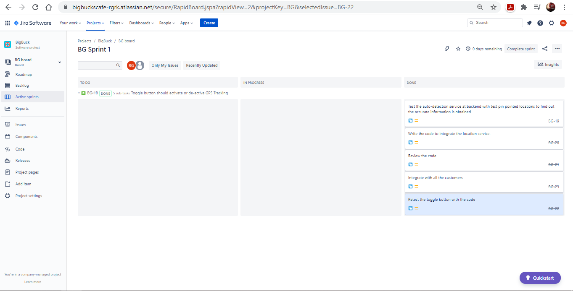

Sprint-1: Reports
Sprint-1: Burn Down Chart
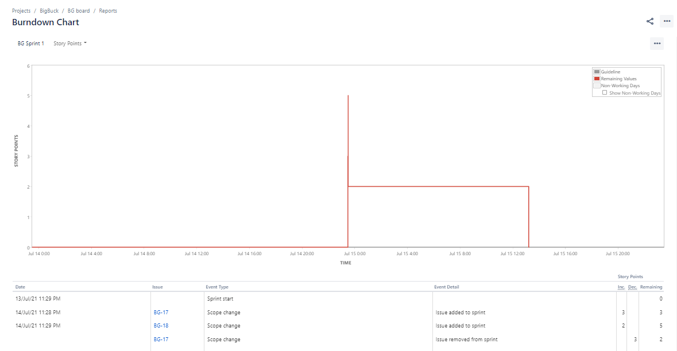
Sprint -1 Burn Up Chart
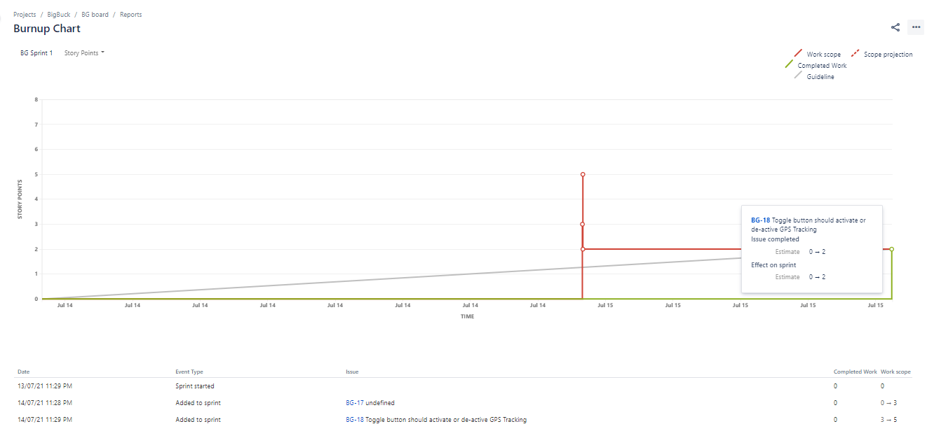

Sprint -1 Velocity chart
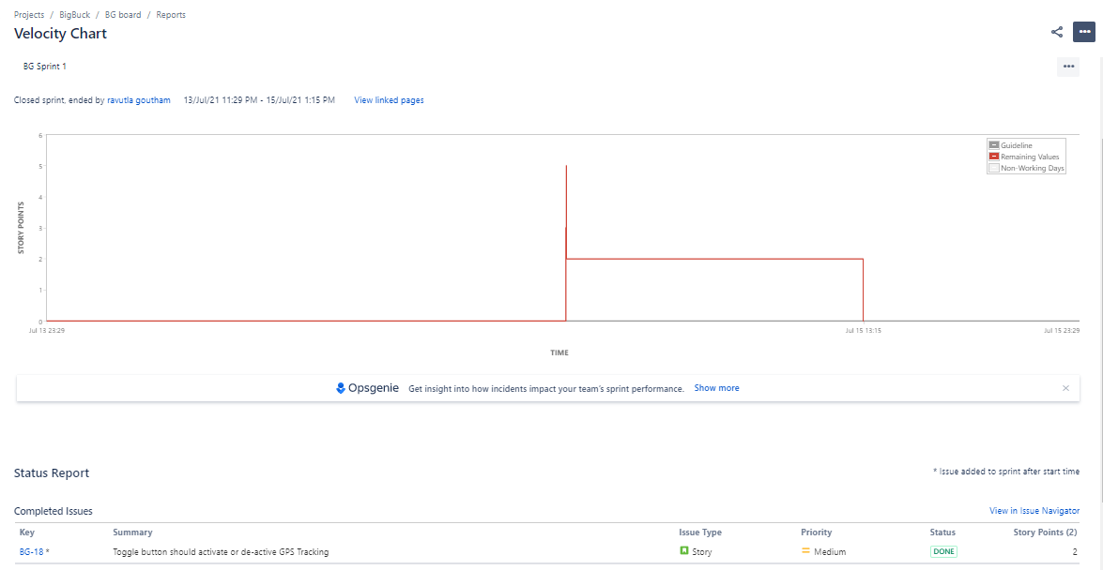

Sprint-2:
Epic-1: Building Easy login for existing customers
Story: Build a service for existing users

ToDo
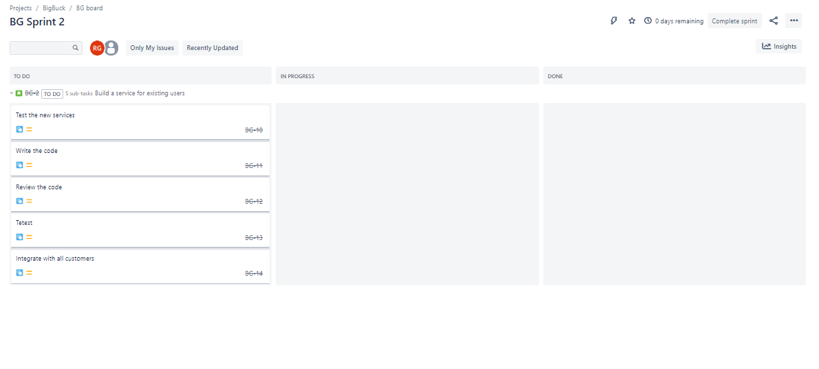
InProgress
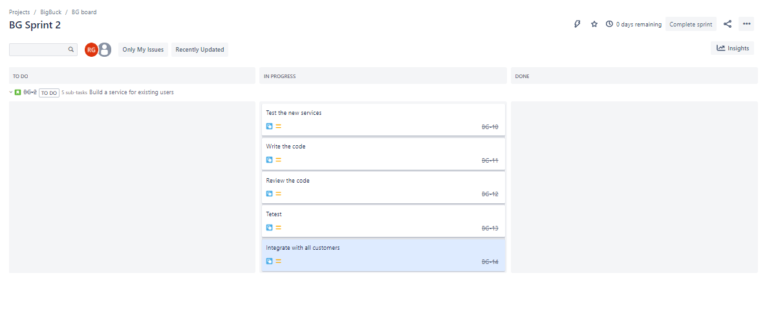
Done
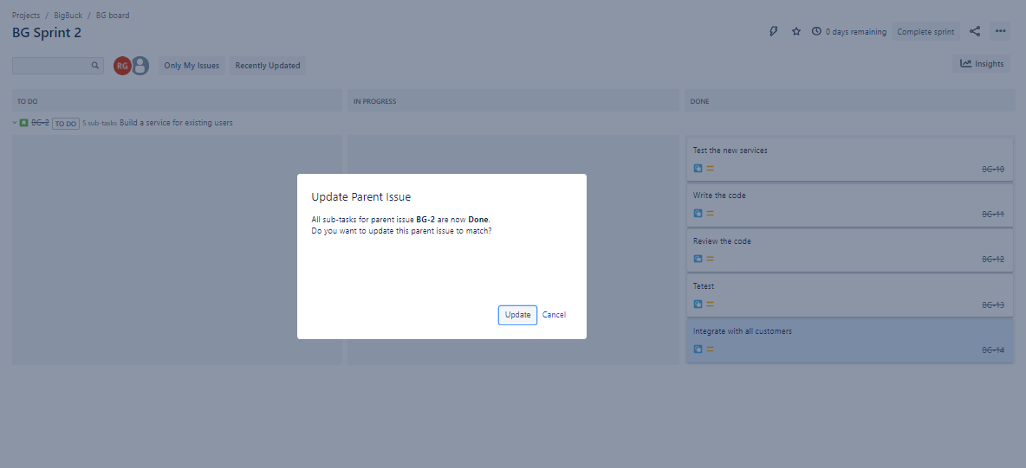

Sprint2: Reports:
Sprint-2: Burn Down Chart
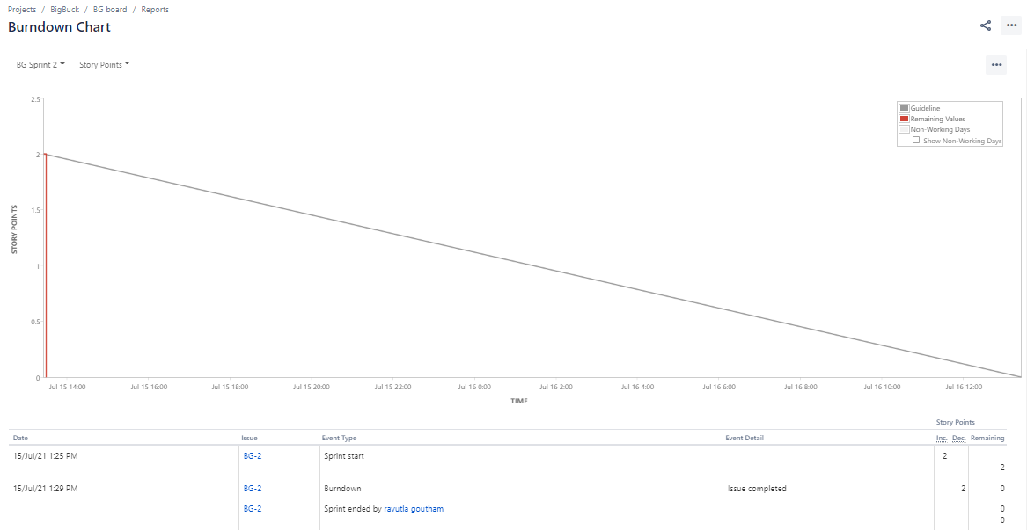

Sprint-2: Burn Up Chart
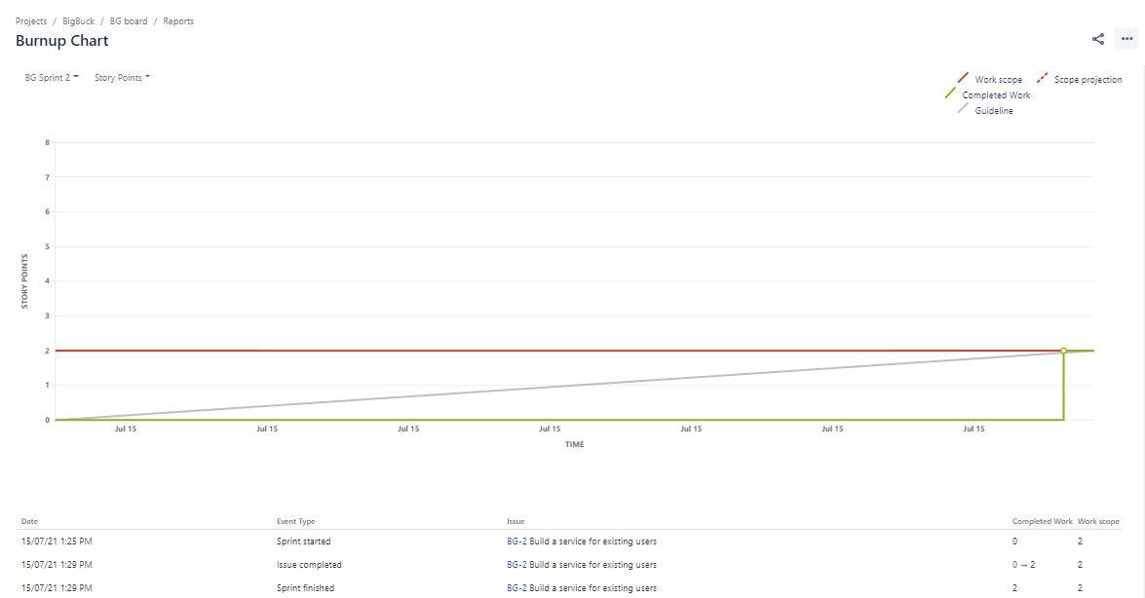

Sprint-2: Velocity Chart
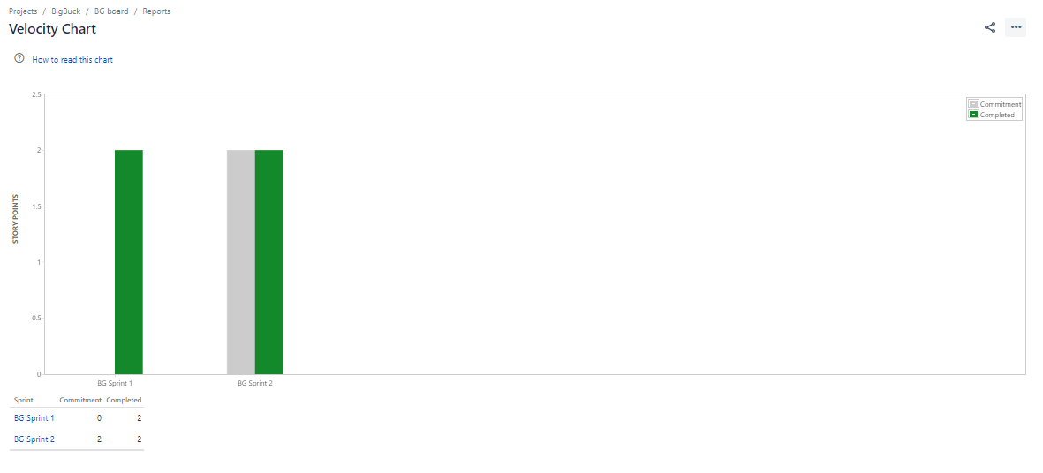

Sprint-2: Sprint Report
